

PROJECT REPORT

# Project Title

**SCHOOL ADMISSION SYSTEM**

*Group Members*

|  |  |
| --- | --- |
| **Name** | **Enrollment** |
| 1. EMAD TARIQ | **02-134221-068** |
| 2. AMMARAH ALI | **02-134221-077** |
| 3. AHSAN NAEEM | **02-134221-082** |

# Submitted to:

# *MISS TOOBA ZAHID*

## INTRODUCTION:

The student admission system contains student data, his personal records, and details of school records. Save time in the entire process by eliminating the need for users to create or create hard documents.

## PERSONAL DETAIL:

Detail of students such as:

* Roll No.
* Name.
* Father name
* Cnic
* Phone Number.
* Address.
* Religion.
* Email address.

## PROGRAMMING LANGUAGE USE TO BULID THIS PROJECT:

* C++

## PROJECT PROBLEM STATEMENTS:

* There are two functions that are doing two different tasks in this project
* One is to enter and save student data and information, and the other is to display a record of the saved student data.

**BENEFITS:**

* This project offers users to enter the data through simple and interactive way. This is very helpful for the client to enter the desired information through such simplicity.
* Through these features it will increase the efficiency, accuracy and transparency.

**OUTPUT:**

## DASH BOARD:

## LOGIN PAGE:

## STUDENT REGISTRATION:

## 

**RECORD:**

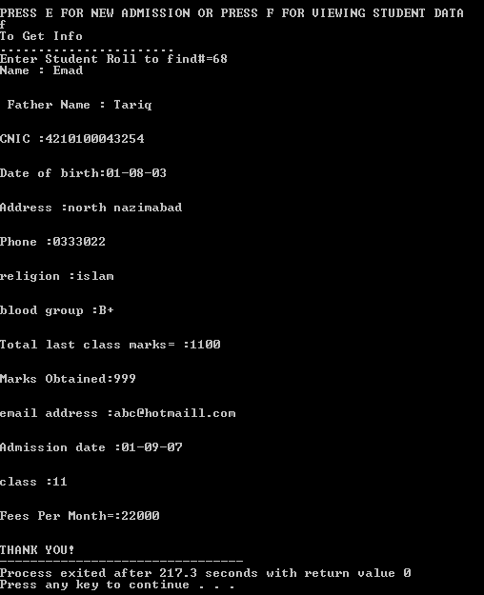

**PROGRAM METHODOLOGY:**

STARTING FROM THE LIBRARIES WE USE C++ LIBRARY IOSTREAM STRING LIBRARY AND FILES LIBRARY AS THE WHOLE PROGRAM IS MOSTLY BASED ON FILING

THEN WE USE IF ELSE STATEMENT FOR USERNAME AND PASSWORD FOR THE SECUIRTY OF THE SYSTEM FROM ANYNONIMOUS PERSONS

Next, we will use two functions of the admission system. The first function inputs student data and saves it to a file. Other function used to view records of stored student data

And finally, refer to both functions under the main function to perform the task

FILENAME USED: filename.c_str()

USERNAME=bahria22

PASSWORD=bimcs

FUNCTIONS: addstudent_data() getstudent_data()

**CONCLUSION:**

This project is basically a web-based application. This means that students can also access and operate the system via the Internet, apply for admission, and view their grades. This system can be used by any institution with general requirements. In this way, we develop a student admission system that helps reduce manual labor, resulting in less staff. Student records can be accessed in seconds. Account clarity. Our system focuses primarily on building efficient and user-friendly communication systems for educational institutions.

THANKYOU!